Drew Scheessele

Mental Health CUI Case Study

Introduction

The access to traditional mental health services such as therapists and counselors can often be prohibitive to people that are not able to afford them, or feel intimidated to speak with someone directly. According to Mental Health America, about 25% of adults that experienced more than 14 mentally unhealthy days a month in 2024 could not see a doctor due to costs (Mental Health America, 2024). Interacting with a chat agent could open new pathways for people to gain access to mental heath services. Chatting with an AI agent allows for no commitment for the user, which some may be concerned about when signing up for a therapy service, be it online or in-person. This becomes a good option for people who feel that they may not need or want therapy, but would like to ask questions about their life every now and then.

The purpose of this CUI concept and chat bot agent will be to converse with the user and to help them check in on the status of their mental health, and also assist them with improving it. The ultimate goal of the agent is to assist the user with processing their thoughts, logging them, and then re-framing them.

As a secondary goal, the concept will also assist the user in maintaining their mental health by providing them with meditation techniques and other coping mechanisms upon request. The tasks for the agent can take the form of structured Cognitive Behavioral Therapy (CBT), meditation guides, and reflective conversations to help the user identify and work towards their goals.

Goals

The goals of this concept are to determine the following:

- Is the user is able to complete a digital agent-based CBT session effectively in a similar manner that they would within an in-person setting?
- Does the user feel confident in talking to the AI Agent and trust it enough to speak about sensitive topics?
- Can the design account for different questions that the user may have about their situation?
- Does the user feel limited in interacting with the agent to the point that they are not able to complete their goals?
- Is the user able to understand the capabilities of the agent?

These goals encapsulate the main objectives of the CUI, which is to provide mental health supplementary therapy that is accessible to everyone. Studies have shown that virtual CBT can be just as effective as in-person therapy, but trust is also necessary in these aspects. While structured during the CBT sessions, the design must be flexible in order to meet the user’s needs where they are at in order to function properly and help the user to understand their own situations.

What is CBT?

The American Psychological Association (APA) describes CBT as a form of psychological treatment that has been demonstrated to be effective for a range of problems including depression, anxiety disorders, alcohol and drug use problems, marital problems, eating disorders, and severe mental illness. Numerous research studies suggest that CBT leads to significant improvement in functioning and quality of life. In many studies, CBT has been demonstrated to be as effective as, or more effective than, other forms of psychological therapy or psychiatric medications.

CBT addresses negative thinking patterns by having the patient break events down into thoughts, feelings, and behaviors. These three categories are then examined using Socratic Questioning to help the patient to understand the way they are processing. According to PsychDB.com, CBT can last between 12 – 16 weeks. Throughout the weeks, the patient is given “homework” which can take the form of behavioral activation, monitoring reactionary thoughts, practicing new skills and coping mechanisms, such as breathing techniques, or even reading and keeping a thought diary. These steps are done with the ultimate goal of re-framing their thoughts to ones that halt the negative thinking process. These tasks can be integrated into a chatbot so that it checks in with the user automatically on a weekly basis to hold “sessions” to go over the user’s thought chart. It would also remember what the user has submitted in the previous weeks for the purpose of reflection. By analyzing the user’s goals, the agent can then issue the user “homework” for the next session based on the user’s goals.

Over time, CBT becomes a process in which the patient is very much becoming their own therapist in some ways. CBT provides patients with tools and the understanding to register automatic thoughts, and then correct them on their own. The therapist or agent acts as a guide for them.

Effectiveness

To provide the user with constructive sessions, a large focus is being placed on CBT. Due to the weekly structured nature of CBT, we can have the agent present this task as an automatic task. Dr. Kanojia states that due to the protocol breakdown of CBT that focuses on thoughts, feelings, and behavior we are able to effectively target certain aspects week-by-week using a framework. A systemic review of AI powered CBT chatbots considered 10 different studies covering three different AI-driven CBT tools: Woebot, Wysa, and Youper. Four of the studies looked at specific populations, including those dealing with substance abuse, health-related mental health, and maternal event experience. Through five studies, it was found across diverse populations that Woebot was effective as a digital therapeutic tool for various mental health challenges. One study among 70 young adults with symptoms of depression and anxiety found significant reductions in PHQ-9 (Patient Health Questionnaire for depression) after two weeks of daily chatbot interactions. Two other studies of Woebot included individuals that were battling substance abuse, the first assessed usability and engagement. This study found high satisfaction and 50% reduction in substance cravings. The second study showed a notable decrease in past-month substance use occasions. Ultimately, through a cross-sectional study it was found that Woebot achieved WAI-SR scores comparable to traditional CBT methods, meaning that it was similarly effective. The studies that covered Wysa and Youper found substantial results in lowering anxiety and depression levels as well (Farzan, Ebrahimi, Pourali, Et al., 2024).

To go along with CBT, less structured and informal tasks shall be implemented into the design of the CUI. Considering the goal of users maintaining their mental health, meditation walkthroughs and open question and answering should also be available.

Limitations

With keeping in mind that humans can sometimes struggle with forming close bonds with agents, the agent should still be able to speak with the user on specific questions and offer reflection so that the user would be able to further understand themselves and what decisions they want to make or how to feel. Over time, AI agents have gotten better at being empathetic, with a study on the Empathetic AI Chatbot, PI, showing that people are having issues discerning between human-human chat transcripts and human-agent transcripts only 47.5% of the time (Kuhail, Alturki, Thomas, Et al., 2024). Despite these advancements, there have been studies that show responses that display empathy, experiences, or complex mindfulness can sometimes come off as inauthentic due them being computer-like and the user being brought back to reality that they are speaking with an AI agent (Seitz, 2024). Reinforcing this finding, Dr. Kanojia’s video mentions that part of the benefit of human-human therapy is the bond and the trust that is formed between the patient and therapist, allowing people to delve deeper, this isn’t always possible to achieve with an AI agent. When training the agent, the data set should be empathetic and understand issues that people might experience socially, but not make references that they’ve had similar experiences.

Trust, safety, and privacy are three very important factors when it comes to mental health, even more so when it comes to a user speaking with an AI agent. The way that the agent converses with the user must follow typical safeguards for AI and dissuade against harmful behavior and use language that doesn’t make the user feel frustrated or disrespect their feelings. Navigating emotionally charge conversations is difficult for humans, so it is important for the agent to use common and empathetic language when responding to the user. The agent should also be able to provide national resources that are online and ones that would be local to the user, upon request.

As with anything on the internet, there is a concern of privacy, where the data is going and how it’s being stored. As mentioned previously, trust and the bond formed by that between human-human therapy can be great building blocks for the patient to open up and that is not always achievable online. This feeling of simply talking to an AI agent may result in the user being more vague in their statements to the agent, so it would be important for the agent to be inquisitive enough to give a response, but not to pry for information if the user refuses. This also requires the system itself to be secure, and for conversations to be isolated to each user.

Designing the CUI

The modality of this chat bot is through either text chat or voice chat. It’s important that the user is able to literally voice their feelings and thoughts, especially if they don’t feel that they are up to typing them out at the moment. The voice/audio component is integral for the guided meditation task, as some meditations would request for the user to close their eyes and focus on breathing, thus disallowing them to read the screen.

The conversation type for the CUI will fall under the “Counseling” type, while the interaction style of the CUI shall be a mix of conversation-centric and visual-centric designs with buttons for options. The conversation-centric interaction style will be used for the CBT sessions, in which the Agent will lead the user in conversation and provide responses back to them by furthering questions about a given context/thought that the user may have. This style will work well for the open question and answering tasks that the Agent will assist with outside of the CBT sessions. The visual-centric interaction style will be tailored for the guided meditations. While the user will still be able to prompt the Agent for exactly what they are looking for, options for available types of meditations, such as breathing exercises and sound baths, should be available as buttons to the user so that they are aware of what is available. This interaction style would also be helpful for control buttons while a meditation is taking place, such as options for starting, stopping, and pausing the meditation.

When it comes to conversation repair, the Agent will need to be prepared for out-of-context questions during a CBT session and maintain the session and work back towards. As mentioned previously, safeguards will need to be implemented in the case of prompts from the user that may contain harmful topics. This will need to be addressed differently than how a typical LLM chat bot may address these by simply stating “I’m sorry, I cannot assist you with that”. These statements must be taken seriously and redirected properly, not dismissed. This can take the form of deescalating the conversation, or providing the user with links to local resources.

Another design aspect that will be important is the Agent’s memory. CBT as a therapy technique can take multiple weeks before it is completed, and even going up to several months in some cases. Each session typically builds on itself, so it is important that the Agent is able to remember past context and use it in future scenarios. Referencing the “homework” step of CBT, at the start of a new session the Agent can help the user reflect on their “homework” and help them understand where to go next. Ideally, it is important for the Agent to bring these up, as the user might not always, or always do the “homework”, in which the Agent can them help talk them through some of it.

Informed Conversations – based on real CBT Sessions

During the process of designing the CUI, I examined real in-person CBT session transcripts, particularly one that was assisting someone work through their PTSD, posted on APA.org. There was a strong display of adjacency pairs throughout the sequences. The pairs included actions such as greetings, inquiries, answers, eliciting, and paraphrasing. These pairs fell under various actions such as open inquiry, user response, and agent instructions. Going through the transcript from APA.org, I was also able to identify specific sections of the task and break the session down into sections. An example follows below:

“Do you mind if I ask you a few questions about this thought that you noticed, “I should have had them wait and not had them go on?” [#thought examination]

“The truck that broke down was the lead truck that you were on. What is the protocol in that case?” [#situation understanding]

“When the second truck took over as the lead truck, what was their responsibility and what was your responsibility at that point?” [#Awareness questioning]

“(Pause) It is certainly sad that they died. (Pause) However, I want us to think through the idea that you should have had them wait and not had them go on, and consequently that it was your fault. (Pause) If you think back about what you knew at the time — not what you know now 5 years after the outcome — did you see anything that looked like a possible explosive device when you were scanning the road as the original lead truck?” [#Challenge User Thought]

“So, in light of the facts that you didn’t see anything at the time when you waved them through at 200 yards behind and that they obviously didn’t see anything 10 yards ahead before they hit the explosion, and that protocol would call for you preventing another danger of being sitting ducks, help me understand why you wouldn’t have waved them through at that time? Again, based on what you knew at the time?” [#Socratic Questioning]

“That seems really important for you to remember. It may be helpful to remind yourself of what you have discovered today, because you have some habits in thinking about this event in a particular way. We are also going to be doing some practice assignments that will help to walk you through your thoughts about what happened during this event, help you to remember what you knew at the time, and remind you how different thoughts can result in different feelings about what happened.” [#Reflection]

These sections display the usual archetype and conversation path that usually takes place within a CBT session.

Prototyping the CUI for Mental Health

While designing the prototypes for the CUI, I created two personas, along with scenarios for both.

1. Lauren
- Gender: Female
- Age: 19
- Occupation: Part-Time Coffee Shop Barista

- Motivations: Lauren wants to be able to spend time and go out with her friends without worrying about her anxiety making her think that she doesn’t deserve to be there or otherwise.
- Goal: Making it to the next week, figuring out what she wants to do with her life
- Values: Friendship, empathy, connection
- Pain Points: Has general social anxiety, feels that negative situations are her fault and doubting herself.

Occasionally, in social settings, Lauren feels as if she is the “odd one out”, when a disagreement between friends arises she usually concludes that it’s her fault. She thinks that it is something she said, or didn’t say, to cause a disagreement. This leads her to think that they may not actually want to spend time with her, or that they want to be with friends. These thoughts then turn into her mentally beating herself up with negative self-talk and feeling down or unwanted.

Being a part-time barista, Lauren is not provided health insurance, nor does she make enough money to afford therapy as out-of-pocket sessions can be pretty expensive and her negative thought patterns continue to grow over time. With the assistance of the Mental Health Companion chat bot, Lauren would have access to a structured form of CBT that is led by the AI Agent to interrupt negative thought patterns. The CBT sessions will allow Lauren to question those thoughts and help her recognize them when they start and how to correct them.

2. Alex

- Gender: Male
- Age: 22
- Occupation: Full-Time College Student

- Motivations: Alex is motivated by his drive to learn and make his way through college, diligently studies and occasionally interacts with other students and goes to extracurricular events.
- Goal: Succeed at academics and be active in the community at all costs.
- Values: Hard work, being diligent, caring about others
- Pain Points: Due to over-committing, they become overwhelmed and anxious about meeting deadlines, supporting different events, and keeping up with life in general.
Alex is intrinsically motivated to work hard and achieve his goals of being a top student, and an active member of his college’s campus in various groups. While spending time to focus on his studies, he also commits to events and meetings that quickly fill his schedule. After some time of doing this, he begins to feel overwhelmed and finds his mind racing with thoughts constantly and despite being able to maintain this for the moment, he feels burnt out and doesn’t seem like he can keep up with everything. Looking for ways to take time out and collect himself, Alex can utilize the Guided Meditation function of the chat bot. The chat bot will lead Alex through guided mediation using breathing exercises, music and sounds, and other instructions to help him re-center himself on busy days.

Using these personas and scenarios, I then built my prototypes that could address each task, the CBT sessions and the Guided Meditations. I created two types of prototypes for these tasks, starting from the base of paper prototypes. First, the “Think Aloud” test. This test is more suited for the text based conversation of the CUI, such as CBT and any questions the user may come to outside of formal sessions. Second, the “Wizard of Oz” test method. This method would be more appropriate for the guided meditation section, as it guides the user through a session in which they may close their eyes and not pay attention to reading the display.

For the structured CBT session a “Think Aloud” test will be performed with a paper prototype to simulate chat messages between the agent and user. The openness of a CBT session, with responses heavily relying on the user’s prompts make this an ideal paper prototype style in order to react and respond with ease. The goal is for the user to gain understanding and break negative thought patterns through the use of CBT. CBT is structured in a way that negative thoughts and patterns, along with initial feelings, first, and then these negative thoughts are challenged with alternatives and coping skills are formed over time. CBT often gives the user some kind of homework from week to week, which can take the form of keeping a thought journal, or challenging oneself through something like exposure therapy, so it would be useful for the Agent to remember notes from session to session. The following images show the paper prototype, and the following dialog shows the full conversation for what a text-based CBT session would look like:
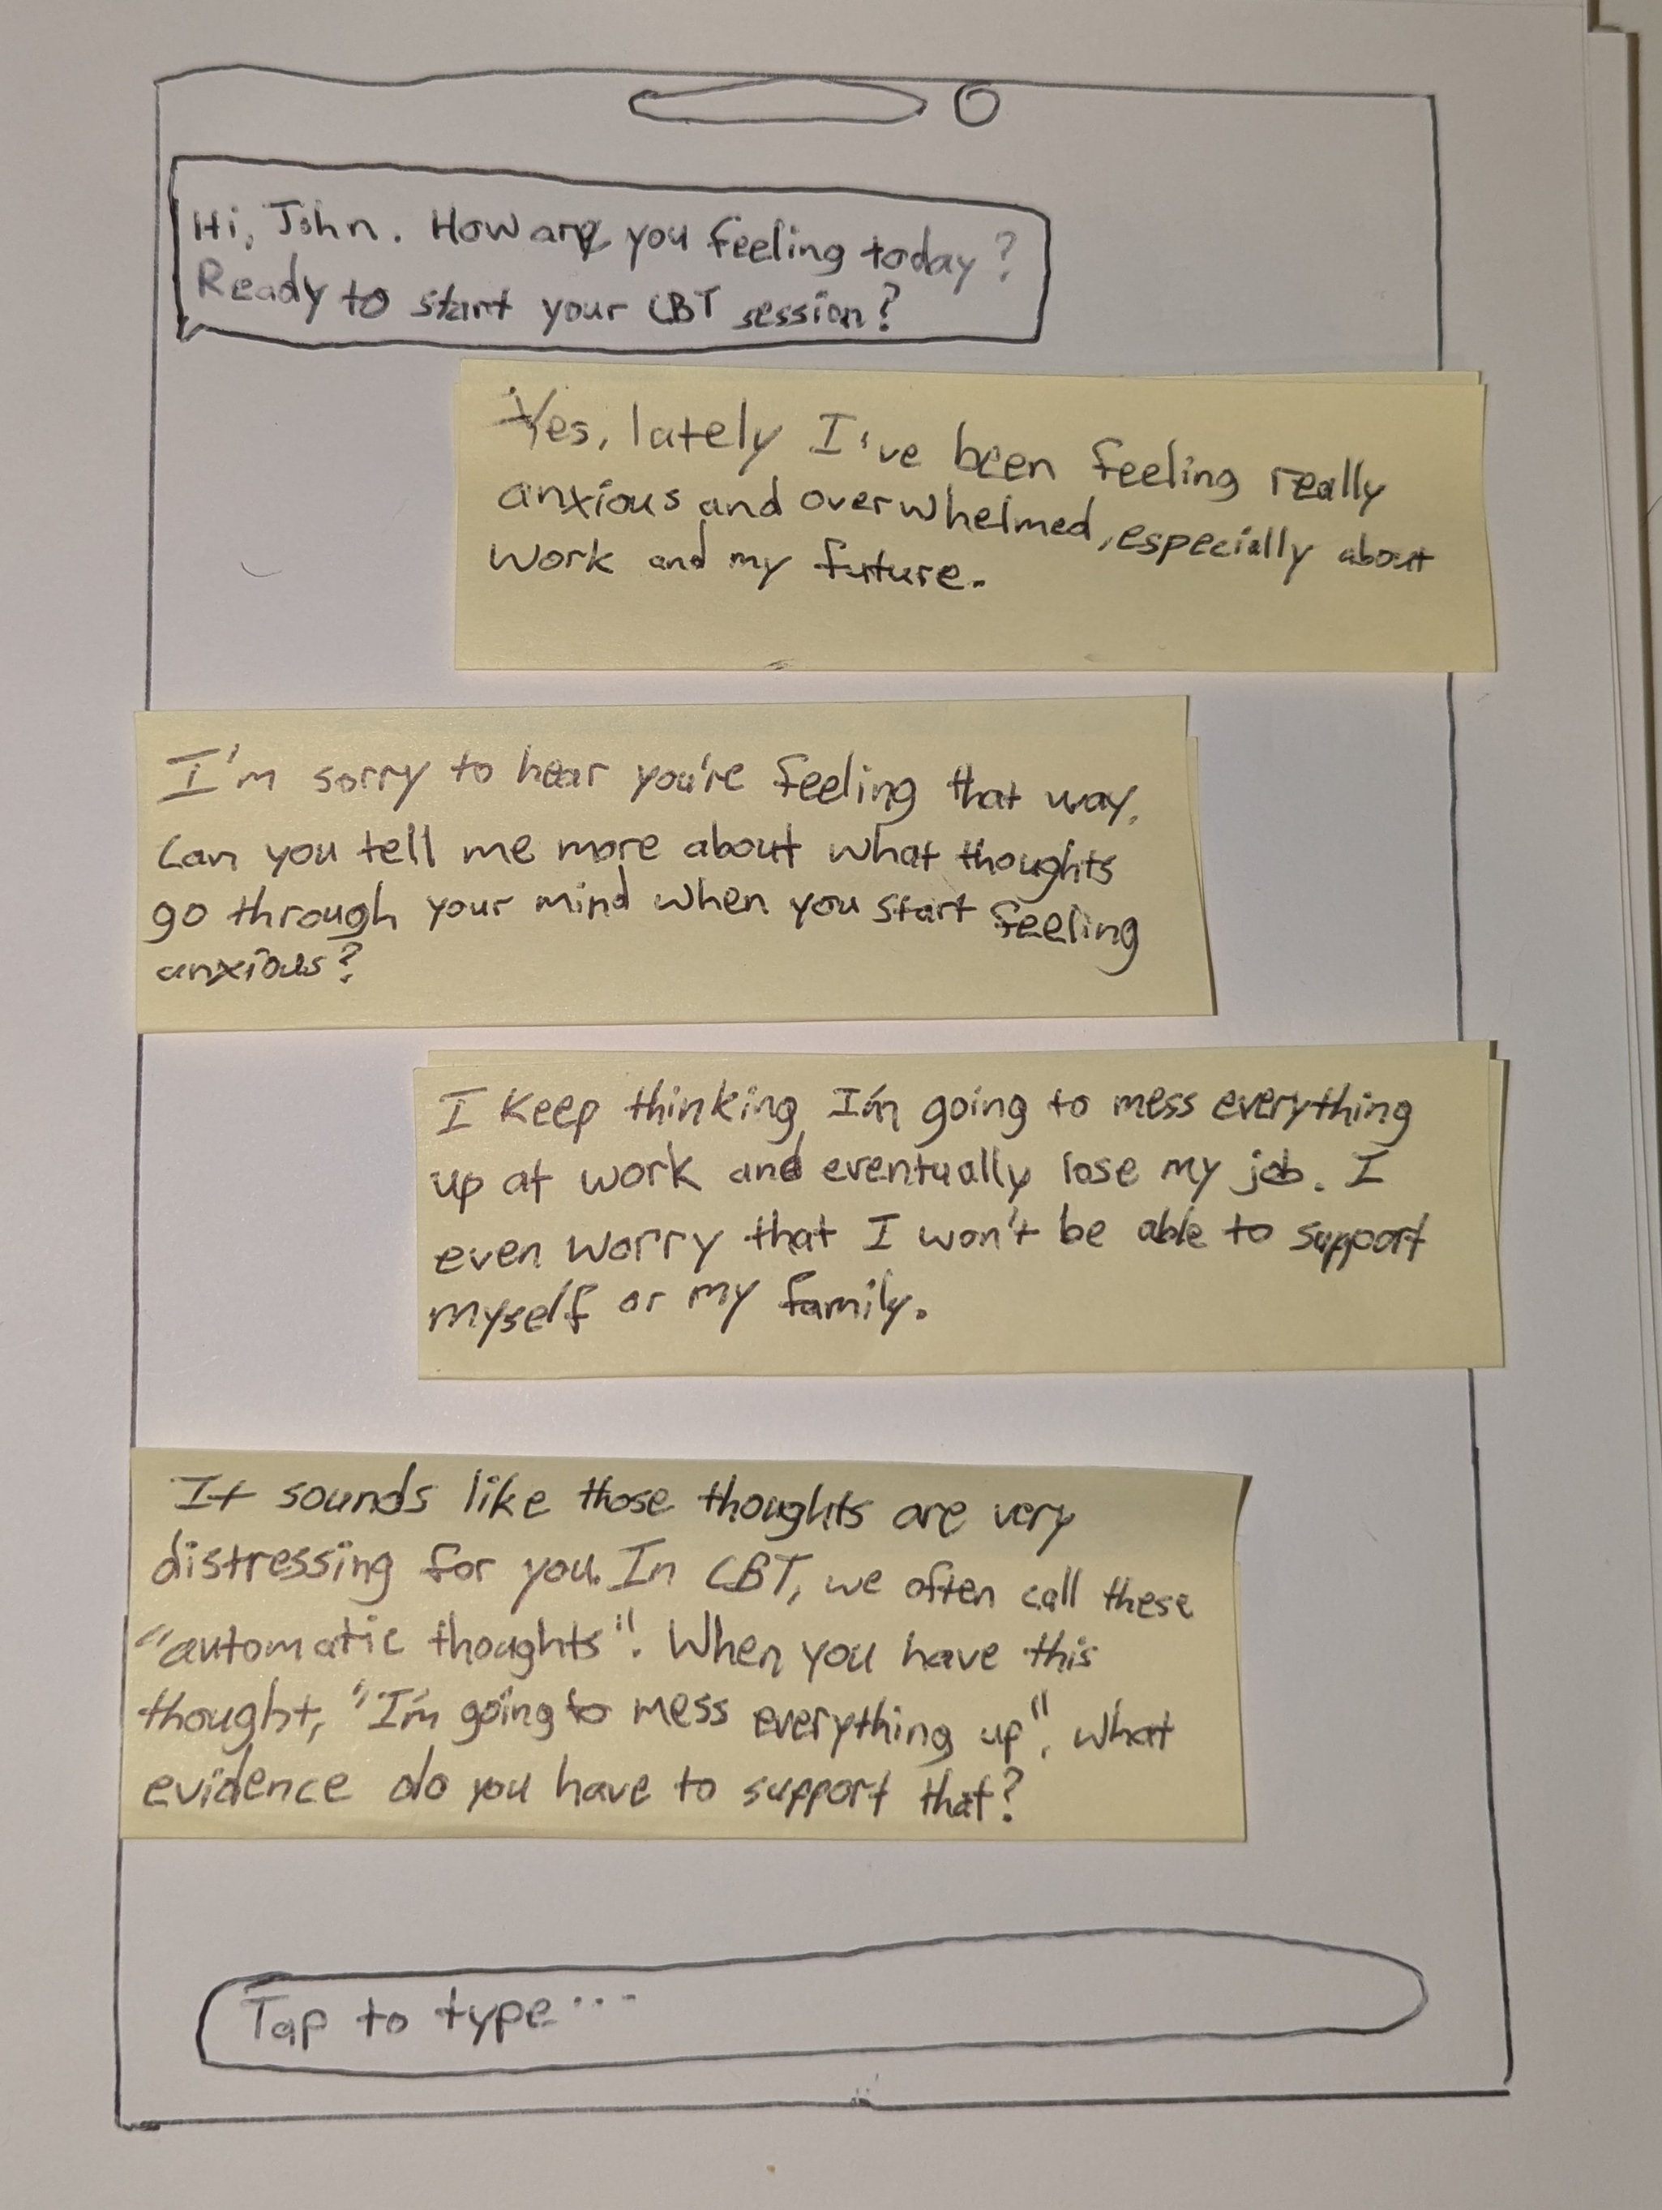Figure 1: CBT CUI Paper Prototype
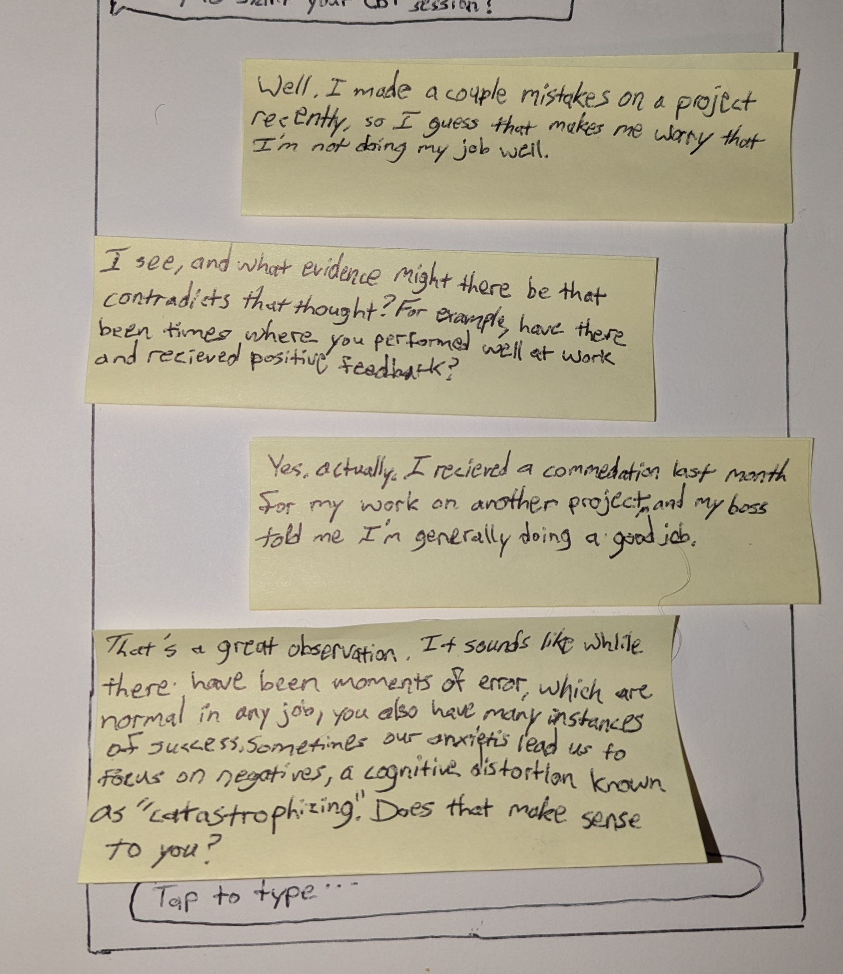

The next prototype, to be used for the Guided Mediation task was created with the testing method of “Wizard of Oz” in mind. This was employed and tested through the use of text messages and then a voice call to simulate the audio instructions and music played during the meditation session. This task would involve buttons for the user to select the type of meditation they would like to do, among other options.

An example of the text portion of the prototype is below, after the final message, the audio mode would engage. The full dialog shows the actions that the Agent would use following the text conversation:

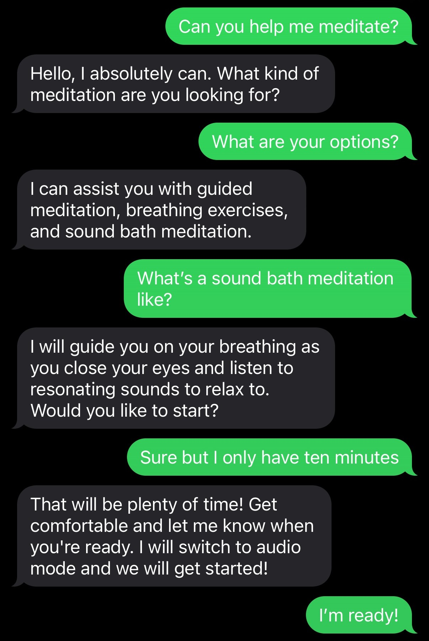Figure 2: Guided Meditation "Wizard of Oz" Prototype

An example of the ensuing voice transcript:

A: Close your eyes, and inhale deeply for 5 seconds. (Sounds start playing)

A: Now, slowly exhale.

A: Let’s repeat...Inhale.

A: And exhale…
A: Great job! The meditation is now complete. Is there anything else I can assist you with at this time?

U: Thank you, that will be all for now!

Initial Testing Results

For the purpose of this project and testing round, my recruitment strategy was based off of convenience sampling. While accessibility and availability played a part in my choices for the test participants due to them being friends of mine, they also bring their own value. The first participant is Jacob R., who is a psychology doctorate student. The second participant is Corey F., who is a web developer.

Participant Demographics

Total Participants: 2

Jacob R.
- Age – 31
- Gender – Male
- Occupation – Psychology Doctoral Student
- General interest in psychology and different therapy techniques. Constantly looks for new solutions and ways to reach people in order to assist them with their mental health.

Corey F.
- Age – 32
- Gender – Male
- Occupation – Web Developer for a bank
- Deals with stress from work and interpersonal relationships outside of work.

Study Procedures

The testing protocol consisted of focus group style questions to help better understand the participants and their needs or current problems with the mental health healthcare system that is available. This served as an introduction to the subject matter being about mental health for the test participants. These questions also gave me additional information of how people think about mental health accessibility and the way they view chat bots and how people could use them. For these questions, I walked my test participants through them and recorded their answers.

The first task uses paper prototyping for the CBT Session task. This task involves a lot of back and forth between the user and the system, in order to resemble a CBT session. During these sessions, the Agent would be responsive and individualized for each user, remembering information from previous sessions in order build and help the user grow and work through their experiences. To perform the paper prototype test, I staged a mock CBT session with my test participants. As this task would be led heavily by the Agent, I started the test by writing down the introduction message to welcome the user to the session. I then had the user respond by writing down their response while reminding them to “think aloud” as we go through the test.

The second task uses a “Wizard of Oz” prototype for the Guided Meditation task. For this task, I requesting the participant to think aloud as we went through the task. During this process, I took notes on my observations of how the participant went through the task and how they explored the different options available to them. In order to supplement the task, which was for them to initiate a Sound Bath meditation session, I played music for the participant and provided voice instructions once the meditation started, such as requesting for the participant to close their eyes and deep breathing techniques.

Findings

Participant Thoughts From Focus Questions.
- They both stated that seeking mental health support professionally can be a daunting and intimidating task, whether that’s from not knowing where to look for help or the action itself of going to a therapist in person.
- One participant stated that there have been times where they have considered therapy, but never looked into it due to the cost that is generally associated with professional help.
- Both participants stated that they are interested in working on and improving mental health state.
- Both participants felt that digital solutions could be a good stepping stone, even if it ends up being the case where they get value from the simple fact of typing out their feelings, such as an online journal.

Overall, the users liked the concept and potential capabilities of the system.
- Both users liked the structured form of the CBT session, partly because they would be familiar with the process for the next session.
- Both users remarked that they felt they would be able to get value out of these conversations and it would help them examine their thoughts and feelings during tough situations.
- One user stated that the structure and flow of the conversation felt similar to that of an in-person meeting with a therapist, and not an agent (The format of CBT assists with this finding).
- Both users liked the idea of having guided meditation with audio.

There were a couple concerns from the participants.
- Therapy is often built upon trust, so it is possible for the Agent to respond in a way that feels robotic, which could break that trust and illusion.
- A privacy notice could be helpful at the start of the CBT session to let the user know that their conversations won’t be shared outside of the application.
- While CBT typically occurs over 6-8 weeks to complete the technique, the users had concerns that they would regularly use the application.

Future Changes and Conclusions

Participants expressed a strong interest in improving their mental health but found traditional therapy intimidating due to cost, uncertainty, and the effort involved. They saw digital tools as a more approachable first step, especially the structured CBT sessions. Overall, the CBT session was well-received. Jacob R. appreciated the familiar format and felt it could help them reflect during difficult moments. However, concerns around trust, robotic responses, privacy, and long-term engagement suggest there is room for improvement.

One change that could be valuable is to make previous CBT sessions and transcripts easily retrievable. Having these to look back on over time can help the user understand how far they’ve come, and the Agent may even be able to reference back to older sessions to reinforce the user. Another change would be to implement privacy notices at the beginning of the CBT sessions to remind the user that the session and its contents are secured. Similarly, a disclaimer would need to be added to state that while the CUI is a tool, it’s not a licensed professional. A third change, would be an option to have temporary chats that aren’t saved, this could be useful if the user wants to ask the Agent a question that is separate from their usual activity, or simply one that they would not like to affect their CBT sessions.
References:

American Psychological Association. (n.d.). Cognitive-behavioral therapy example. https://www.apa.org/ptsd-guideline/resources/cognitive-behavioral-therapy-example

Dr. Alok Kanojia (HealthyGamerGG). (2023, May 18). Can AI replace therapists? | Psychiatrist explains [Video]. YouTube. https://www.youtube.com/watch?v=3BgdhHXJ-CU

Farzan, M., Ebrahimi, H., Pourali, M., & Sabeti, F. (2024). Artificial intelligence-powered cognitive behavioral therapy chatbots: A systematic review. Iran J Psychology, 20(1). https://doi.org/10.18502/ijps.v20i1.17395

Grover, A., Diwedi, R., & Ahmed, S. (2024, August 23). AI meditation apps: Role in easing stress & enhancing well-being of final year university students. The International Journal of Indian Psychology.

Kuhail, M. A., Alturki, N., Thomas, J., & Alkhalifa, A. K. (2024). Human vs. AI counseling: College students' perspectives. Computers in Human Behavior Reports. https://doi.org/10.1016/j.chbr.2024.100534

Mental Health America. (2024). Mental Health America adult data. https://mhanational.org/issues/2024/mental-health-america-adult-data

PsychDB. (n.d.). CBT. Retrieved February 2, 2025, from https://www.psychdb.com/psychotherapy/cbt

Seitz, L. (2024). Artificial empathy in healthcare chatbots: Does it feel authentic? Computers in Human Behavior: Artificial Humans.

